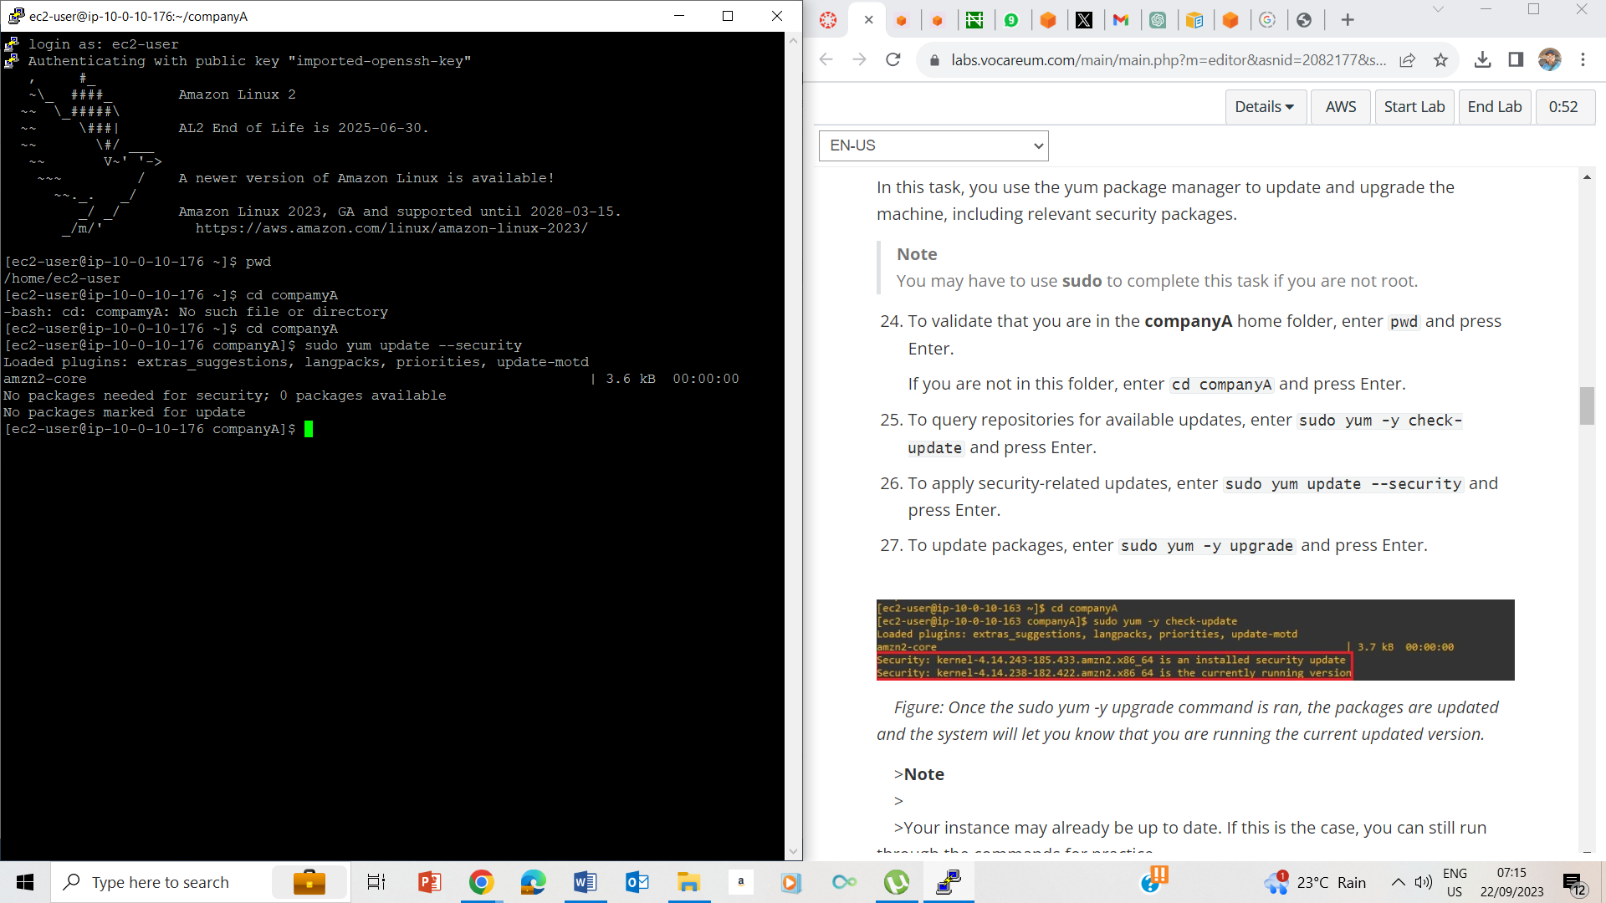

24-25

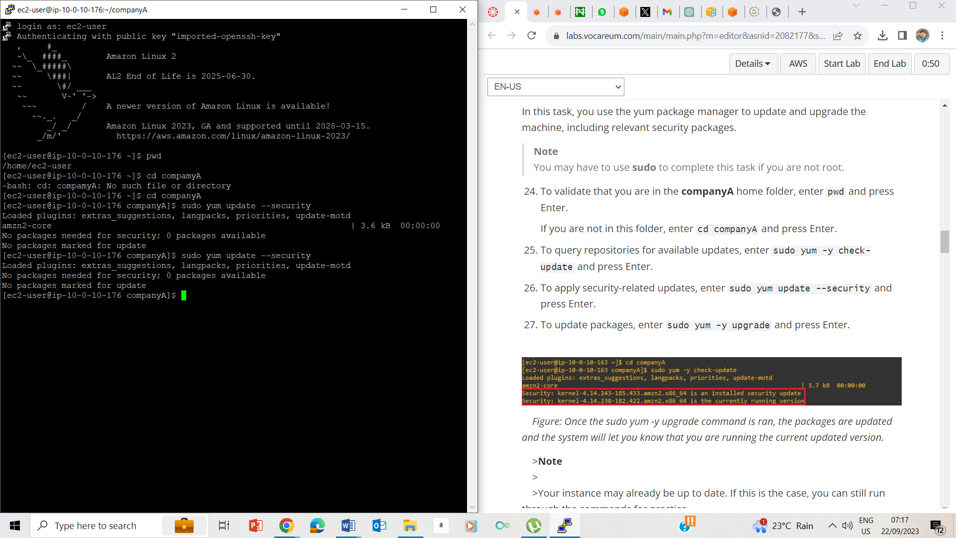

26

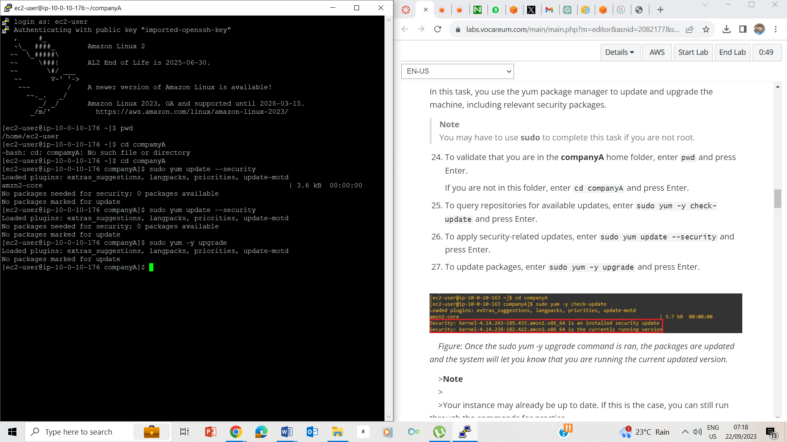

27

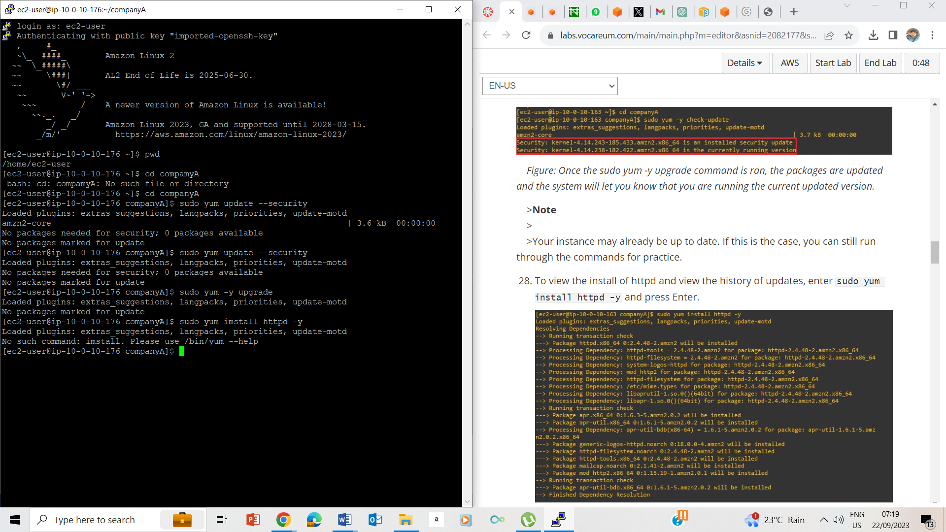

28. History of updates

**Task 3: Roll back a package**

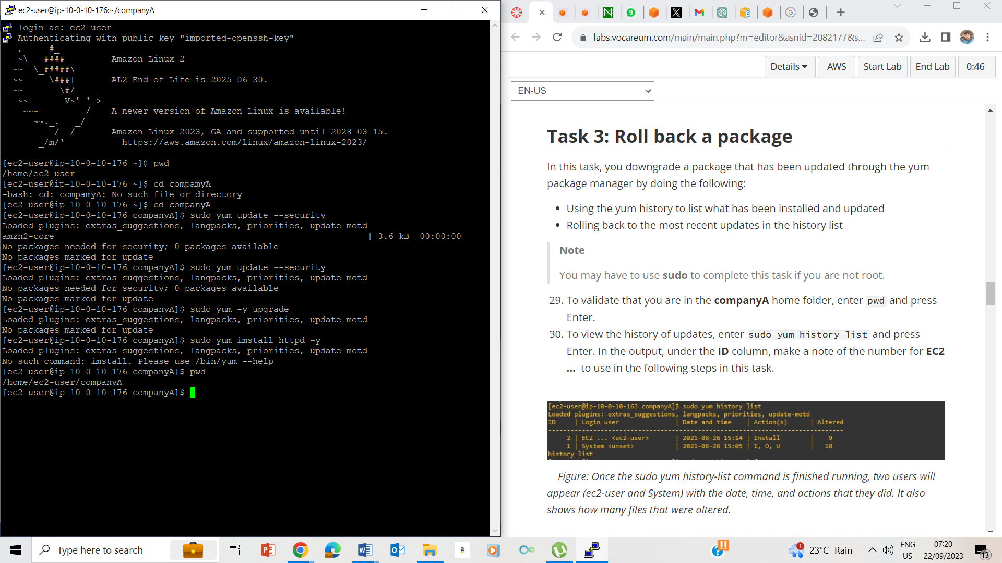

29. Vaidating that I am in companyA folder

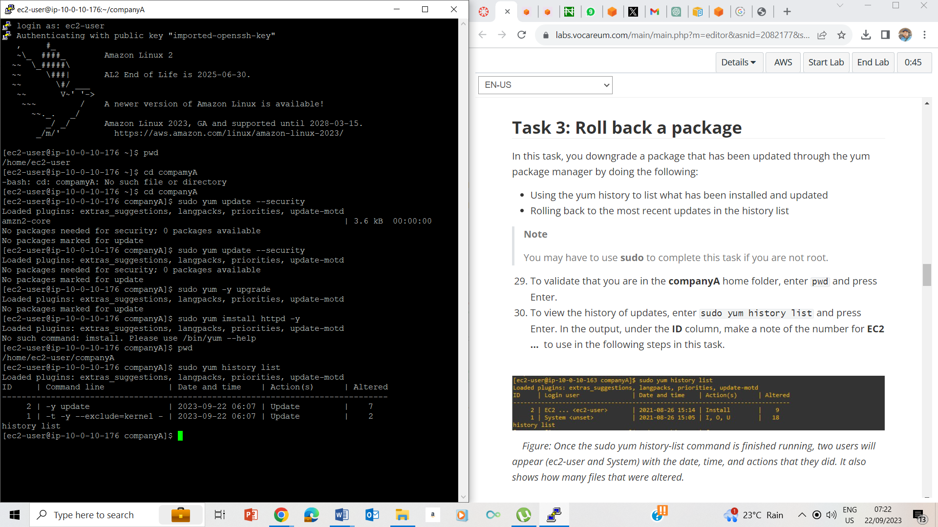

History list

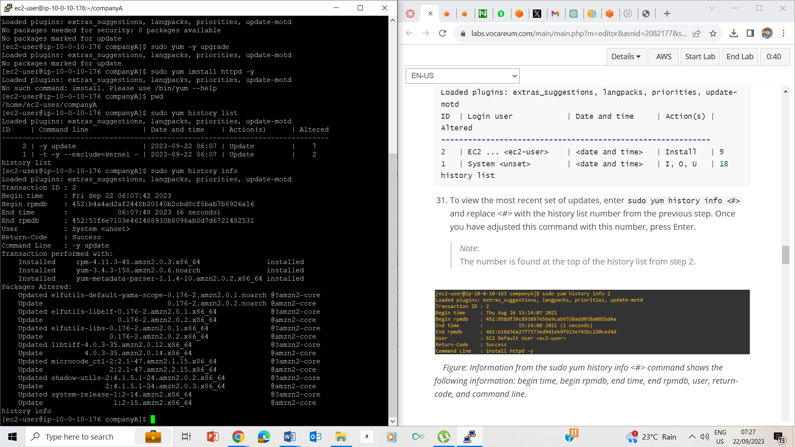

31. History info

## Task 4: Install the AWS CLI on Red Hat Linux

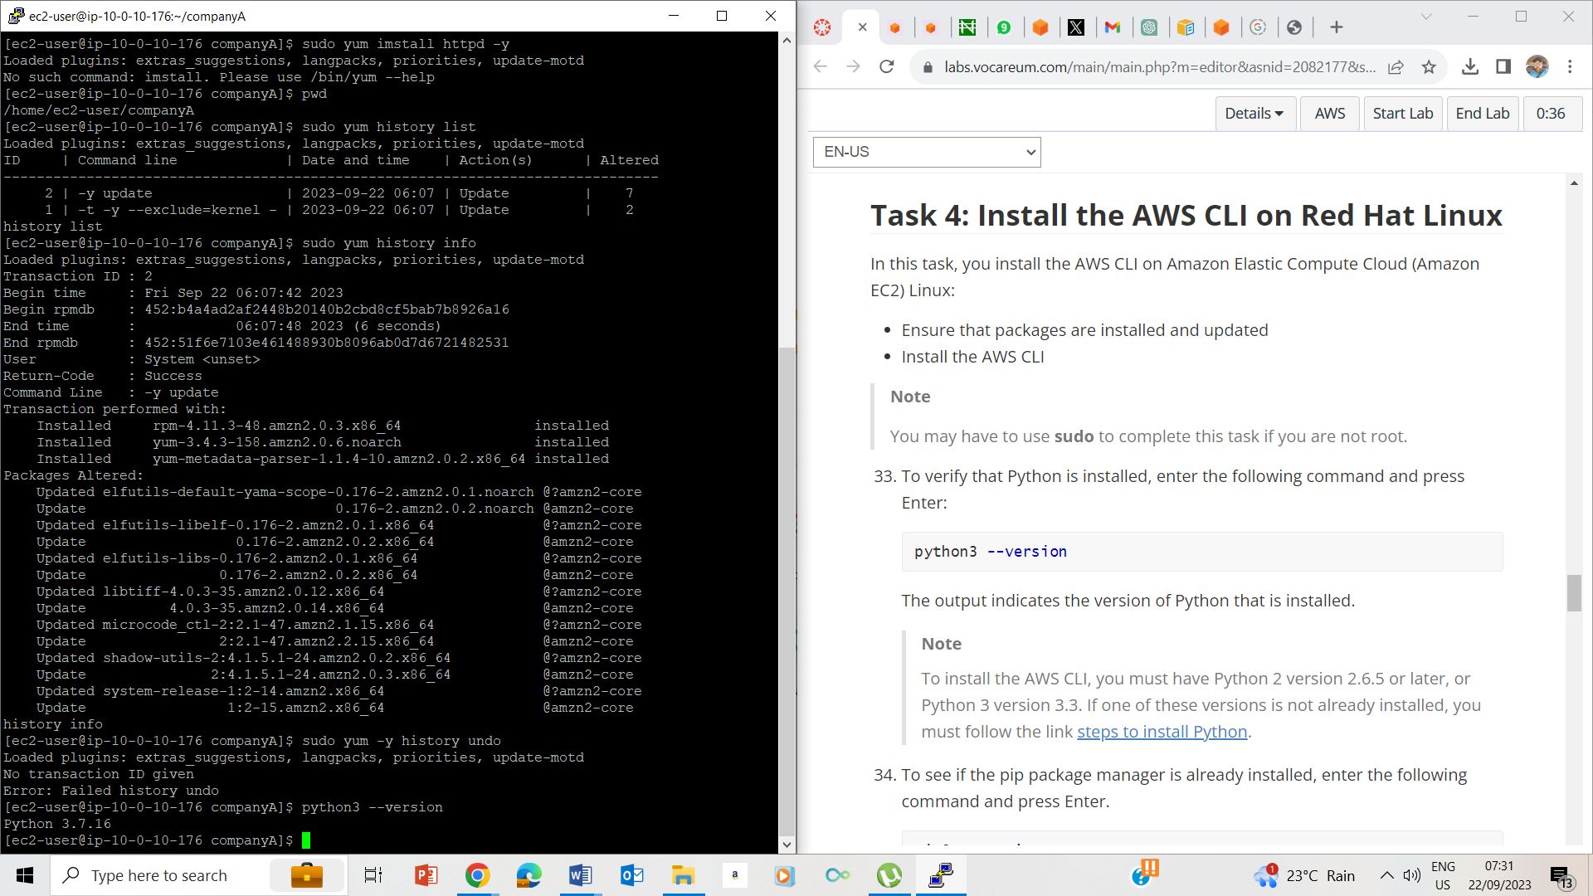

33. Python version = python 3.7.16

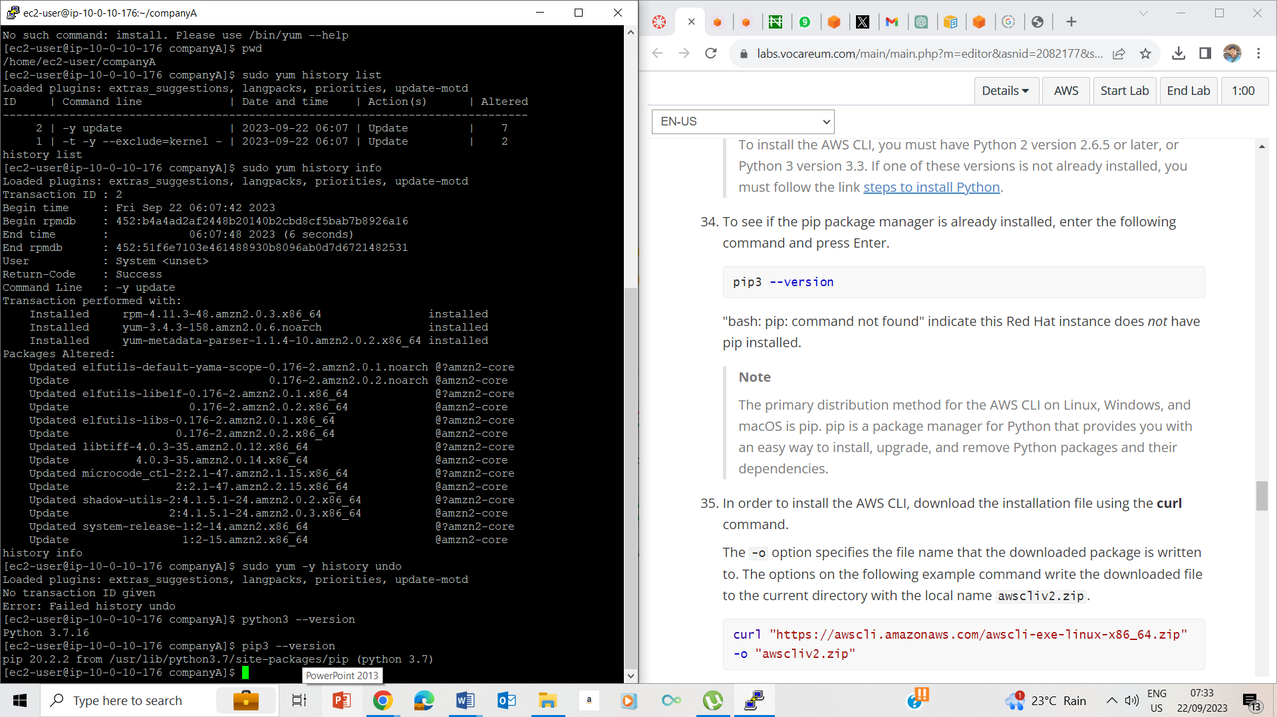

34. Pip version

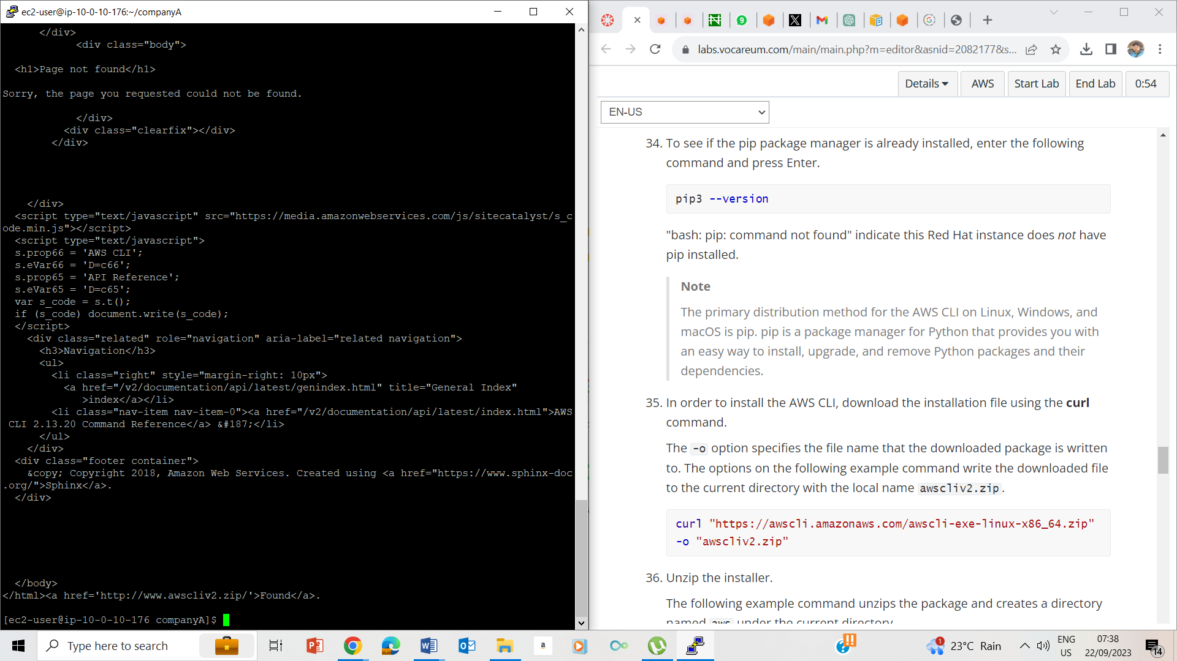

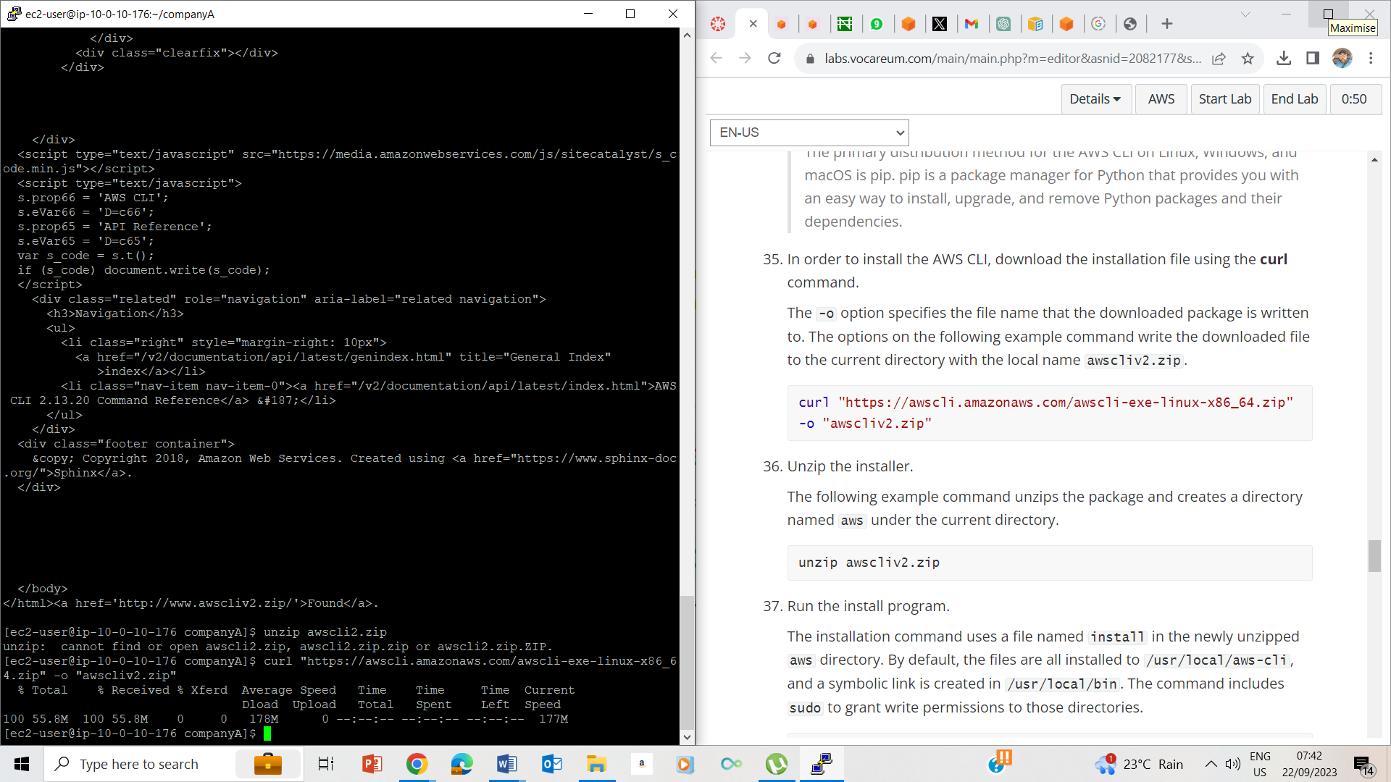

35. Installing the AWS CLI

MY SYSTEM LOGGED OUT AND I RESTARTED

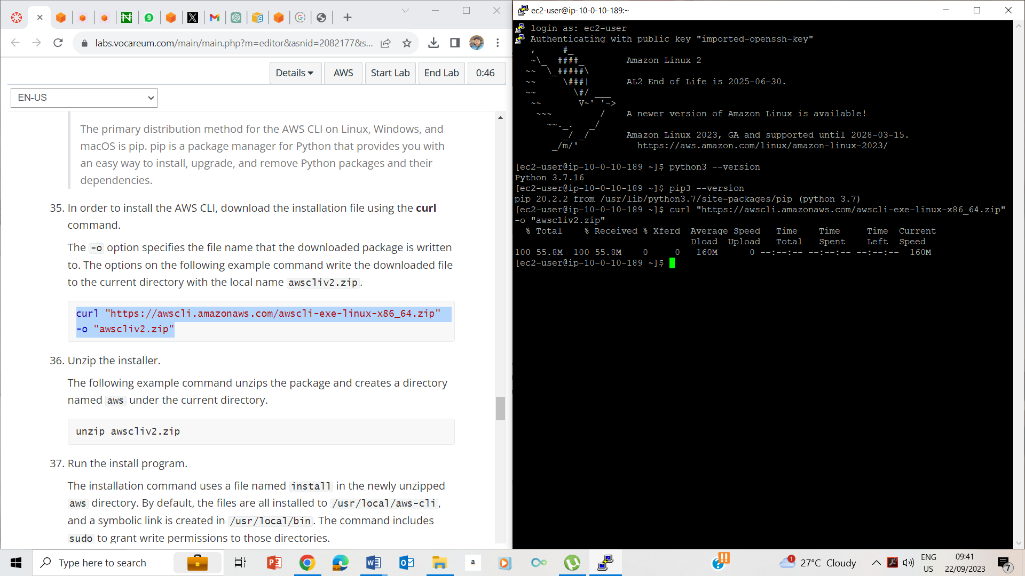

36 Installing the AWS CLI

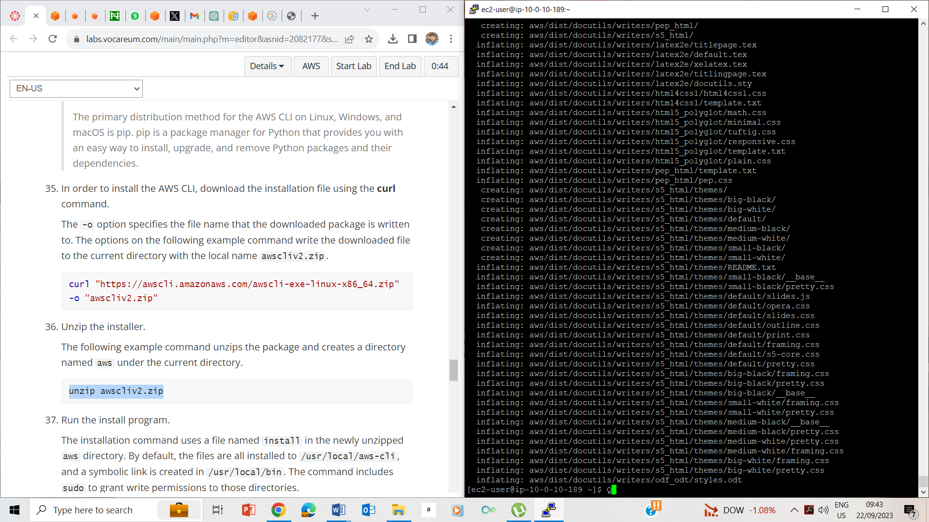

35-36. Unzipping the installer

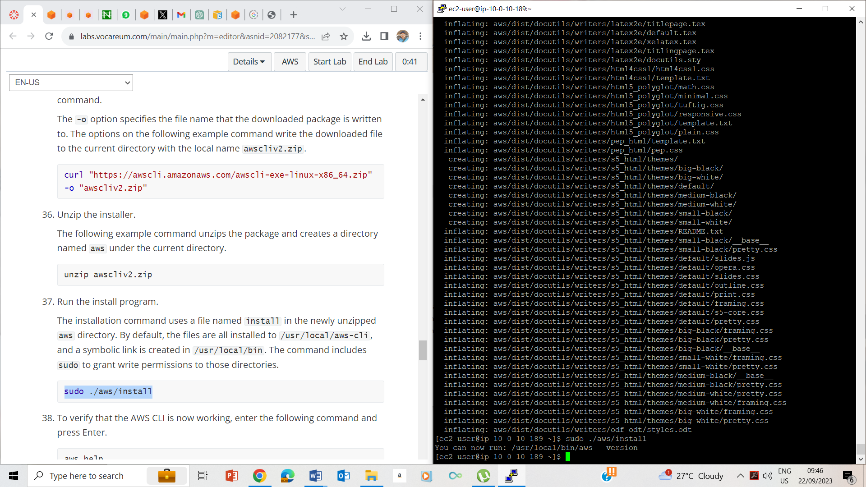

37. Running the install program

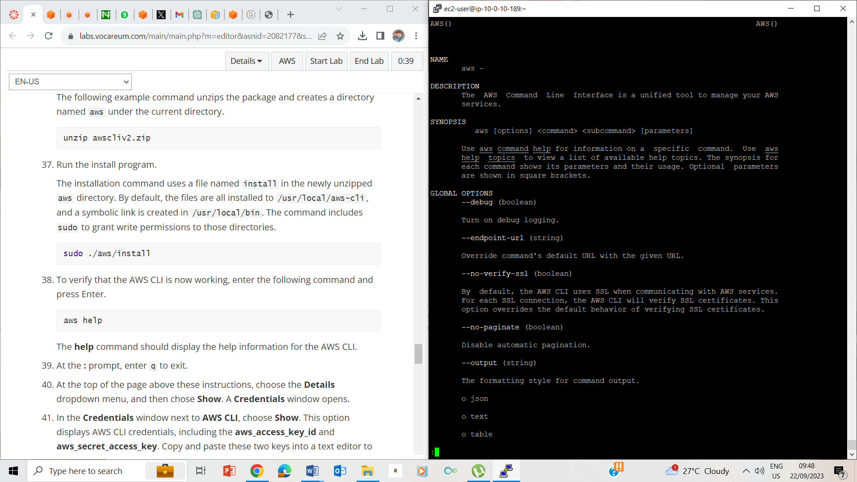

38. aws help

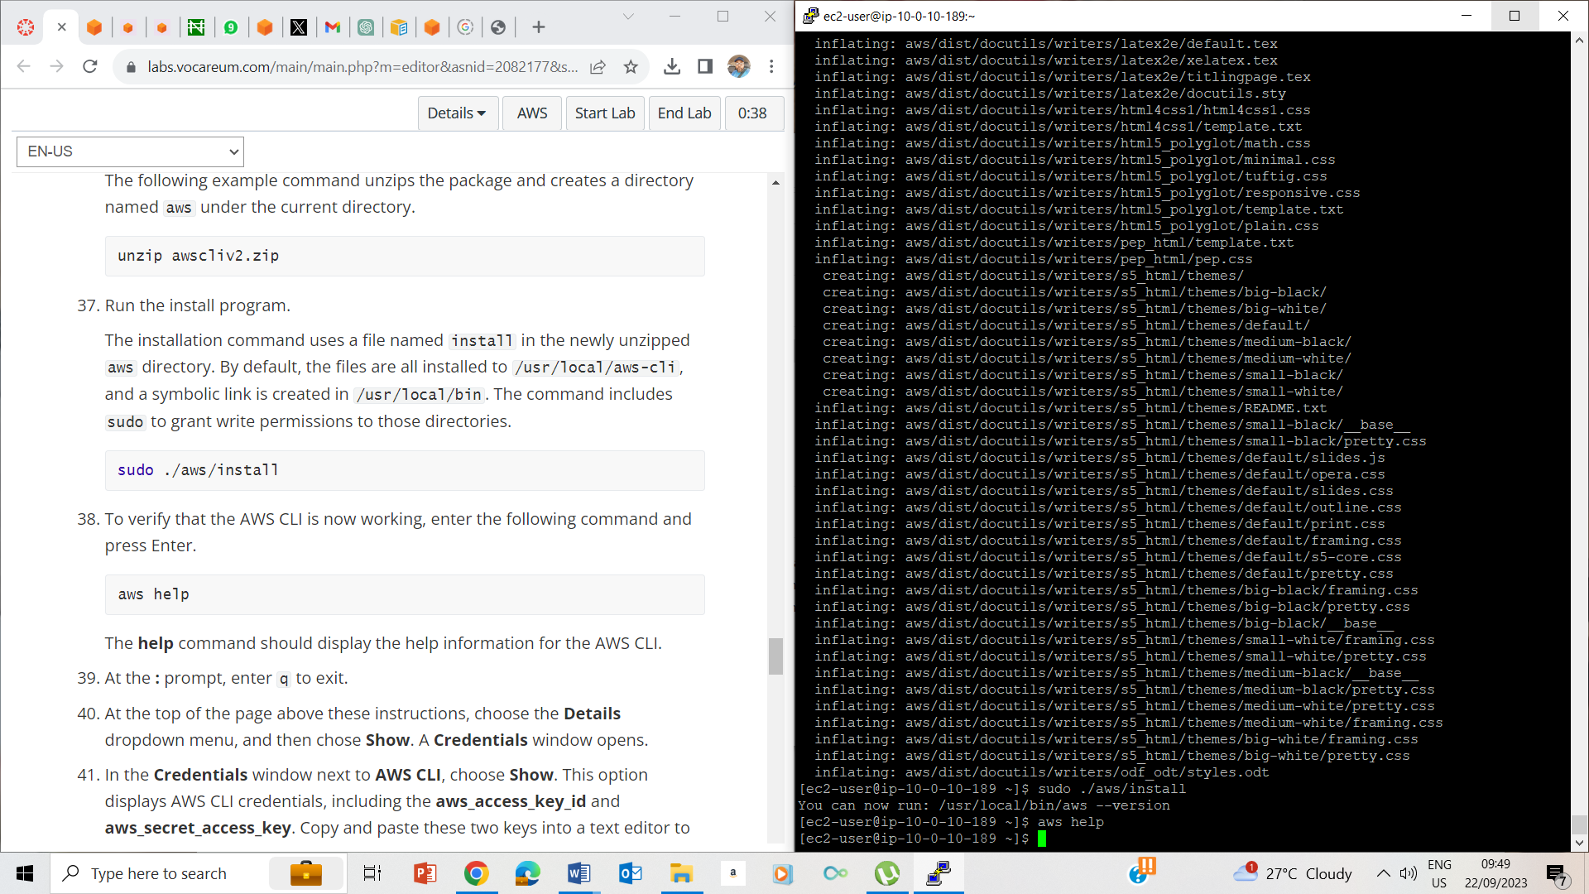

39. q to exit

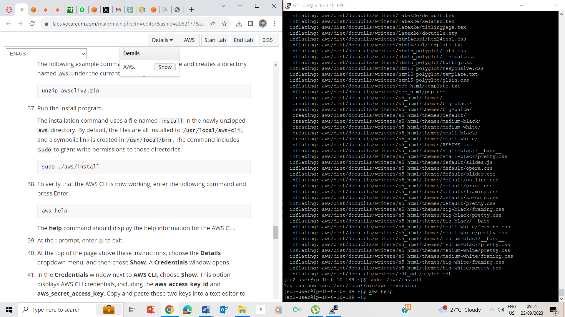

41. Details - >> show



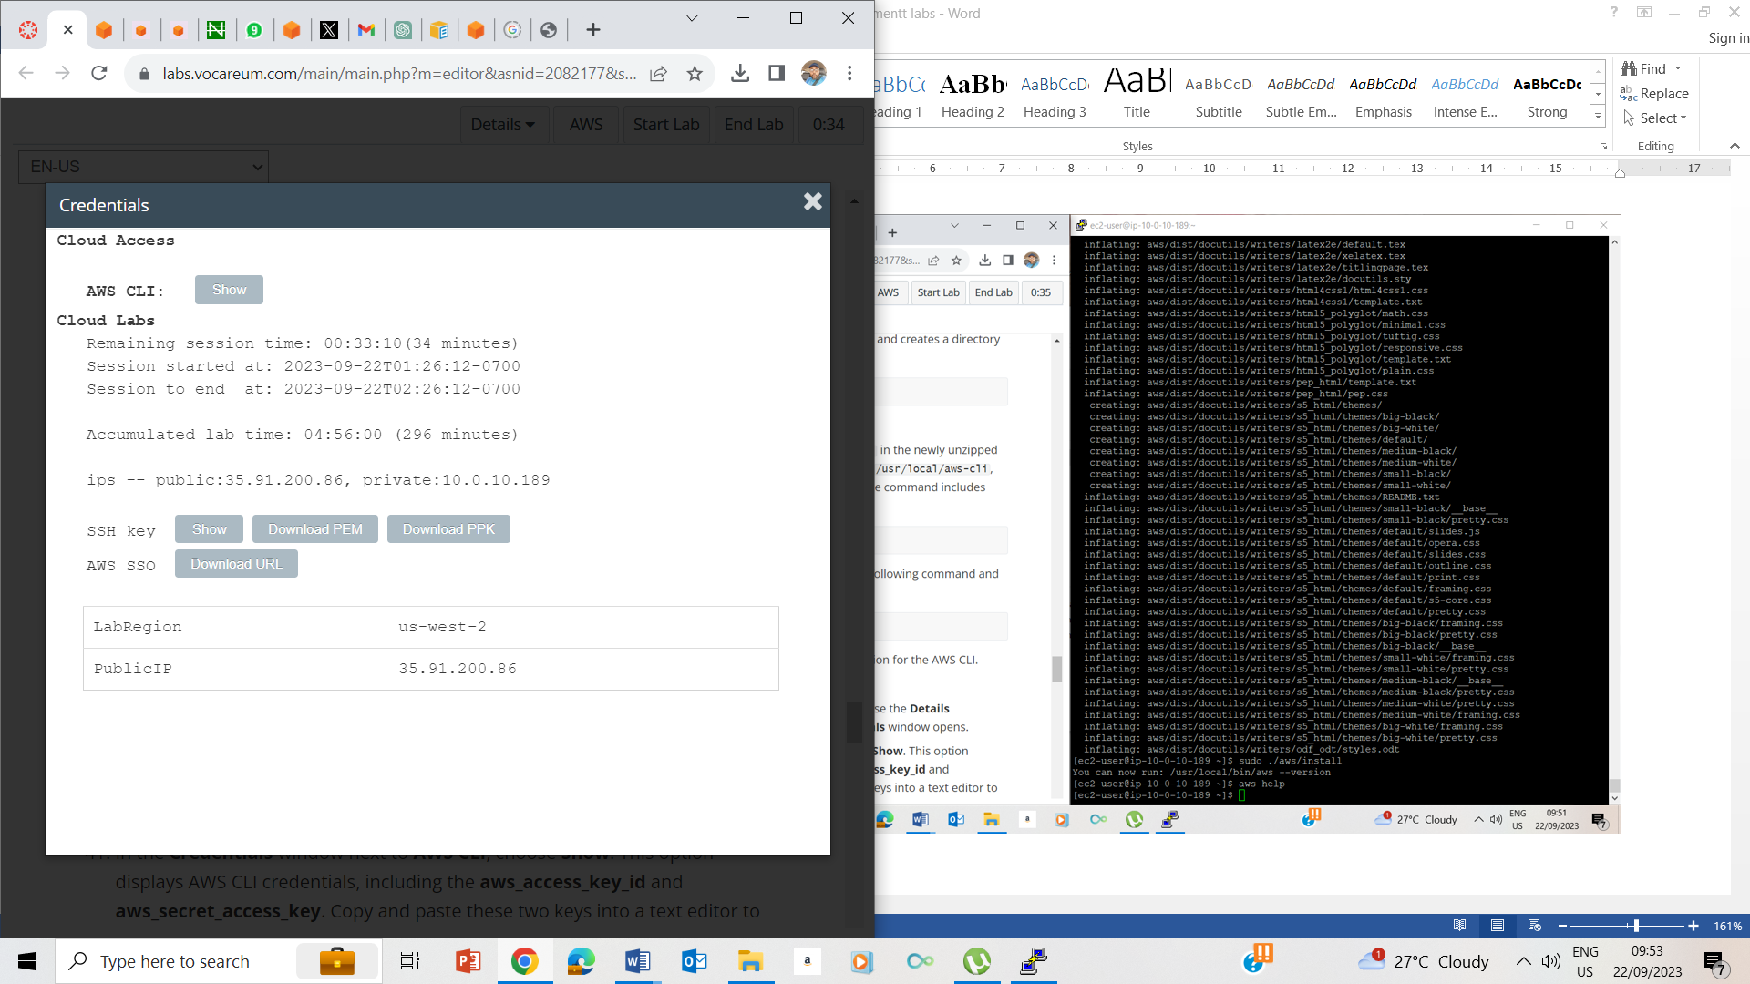

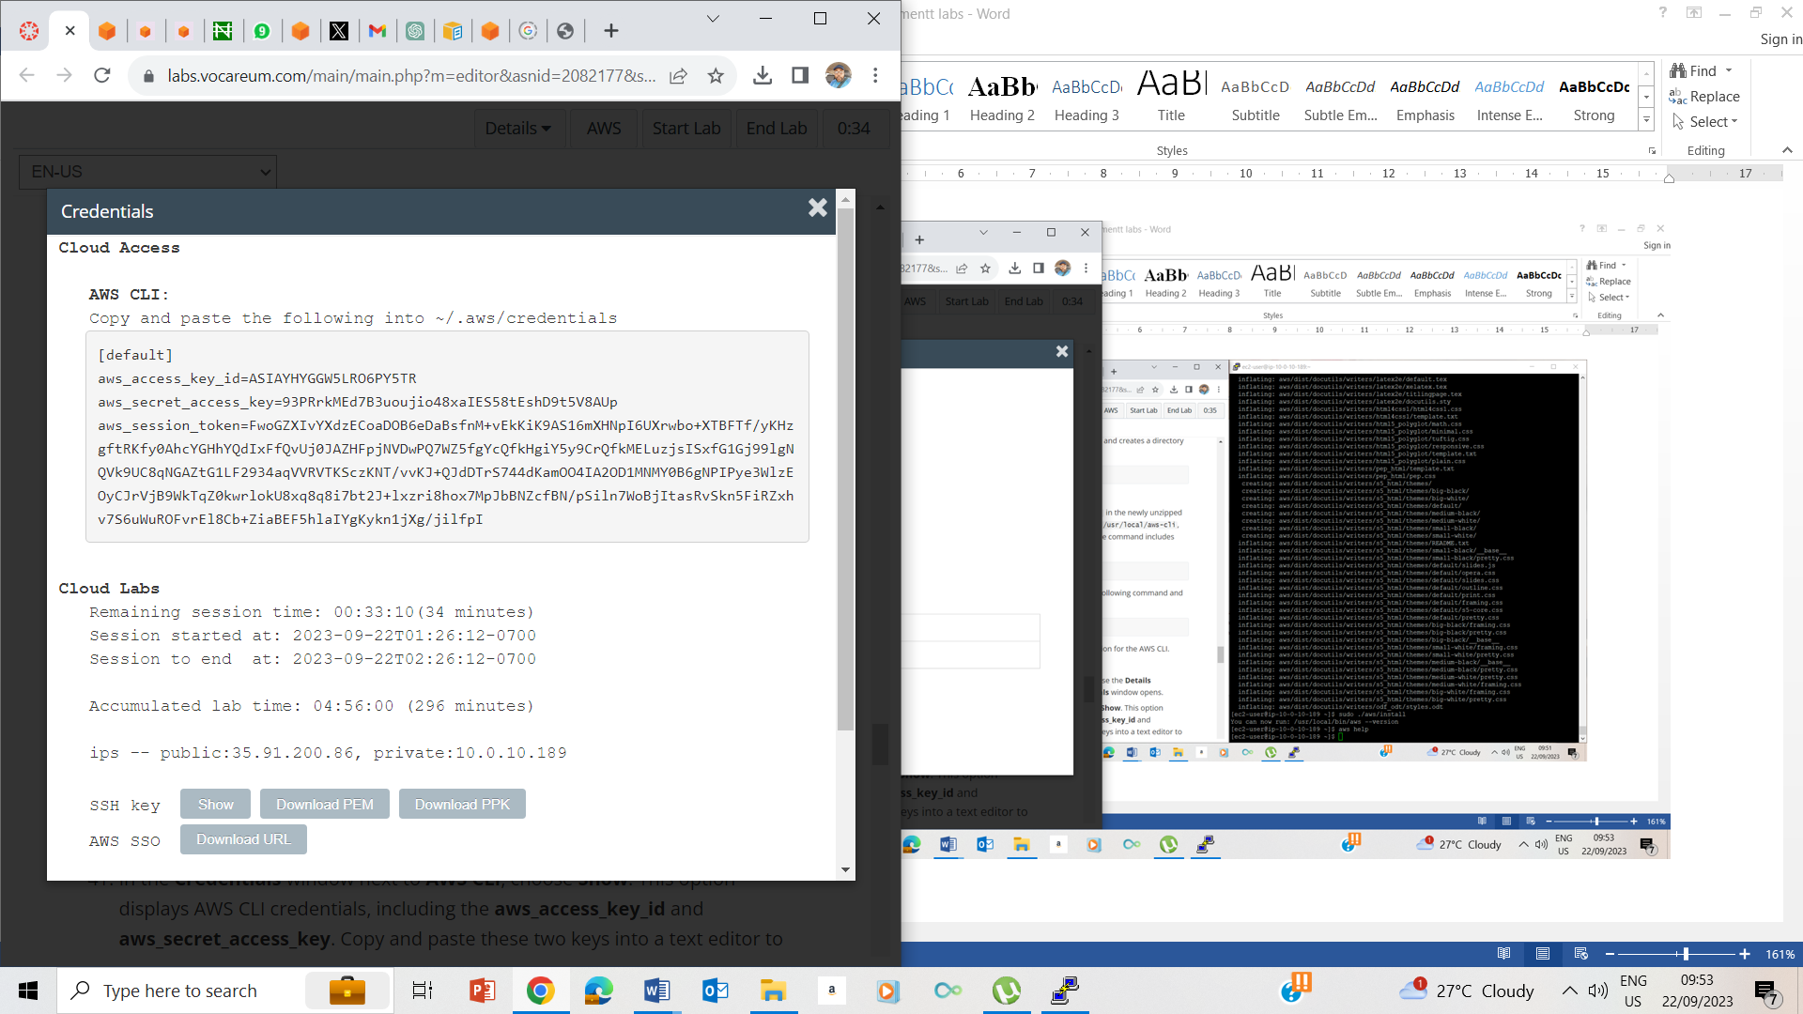

40-41. Noting the aws_access_key_id and aws_secret_access_key

## Task 5: Configure the AWS CLI to connect to your AWS account

## 

## 41-45

## 

## 46-47

## 

## 49-50

## 

## 

## 

## 50. Choose instances running

## 

## 51. Selecting command host

## 

## 

## 

## i-0dda7918c97c31ac0

## 51. Copying the instance id

## 

## 52. Running the command.

## 

## 53. Result

## END OF LAB

## 

## 

## 

## 

## 